**Lab Report 4**

## **Aim**

To apply spatial domain filters on the images and enhance the images in MATLAB.

## **Theory**

##### **Spatial filters** are one of the most commonly used techniques in image processing. They are used to enhance or suppress certain features in an image by altering the pixel values within a given neighbourhood of each pixel in the image.

##### A spatial filter works by replacing the value of each pixel with a weighted average of the values of its neighbouring pixels. The weights assigned to each neighbouring pixel depend on the type of filter being used and the distance of the pixel from the centre pixel.

##### There are two types of spatial filters: linear and non-linear. Linear filters are those that use a fixed kernel or matrix to calculate the weighted average of the neighbouring pixels. Examples of linear filters include the mean filter, median filter, and Gaussian filter. These filters are widely used for noise reduction, image smoothing, and edge detection.

##### Non-linear filters, on the other hand, use a varying kernel to calculate the weighted average of neighbouring pixels. Examples of non-linear filters include the maximum filter, minimum filter, and bilateral filter. These filters are used for tasks such as image sharpening, feature extraction, and image segmentation.

##### In summary, spatial filters are a powerful tool in image processing for enhancing, filtering, and segmenting images. The choice of filter depends on the specific task at hand and the characteristics of the image being processed.

**Mean filter**: This filter is used to reduce noise in an image by replacing each pixel value with the average value of the neighbouring pixels within a given kernel. The mean filter is a linear filter and is commonly used for smoothing and blurring an image.

**Median filter**: This filter is used to remove salt-and-pepper noise in an image by replacing each pixel value with the median value of the neighbouring pixels within a given kernel. The median filter is a non-linear filter and is effective in preserving edges in an image.

**Gaussian filter:** This filter is used to blur an image by replacing each pixel value with the weighted average of the neighbouring pixels within a Gaussian kernel. The Gaussian filter is a linear filter and is commonly used for smoothing an image while preserving its edges.

**Laplacian filter**: This filter is used for edge detection in an image by highlighting areas of high spatial frequency. The Laplacian filter is a non-linear filter and is commonly used for sharpening an image.

##### **MEAN AND WEIGHTED-MEAN FILTER**

**Mean Filter:**

The mean filter is a popular type of spatial filter used in image processing to remove noise and smooth out an image. It works by taking the average of the pixel values within a given kernel or window and replacing the central pixel with this average value. The size of the kernel determines the degree of smoothing that is applied to the image. The mean filter is a type of linear filter because the output value is a linear combination of the input values. The filter kernel is typically a square or rectangular matrix of equal size to the kernel window. The mean filter is easy to implement and computationally efficient, making it a popular choice for basic image processing tasks.

**Weighted Mean Filter:**

The weighted mean filter is a variation of the mean filter that assigns different weights to the pixel values within the kernel window. The weights are based on a predefined kernel function that assigns higher weights to the pixels closer to the centre of the kernel and lower weights to the pixels further away from the centre. The weighted mean filter is also a type of linear filter because it calculates a weighted average of the input pixel values. However, the weights are different for each pixel and are based on the kernel function.

The advantage of using a weighted mean filter over a regular mean filter is that it can better preserve edges and other fine details in the image, while still reducing noise and smoothing out the overall image. The choice of kernel function and its parameters can have a significant impact on the output of the filter, and the selection of the appropriate kernel function depends on the specific characteristics of the image being processed.

##### **CODE**

% MEAN FILTER

fprintf('please Select an image');

y=uigetfile('*.*');

i=imread(y);

k=rgb2gray(i);

%j=imnoise(k,'salt & pepper',0.1)

d = padarray(k,[1 1],0,'both');

[r,c]=size(d);

for R =2:(r-1)

for C=2:(c-1)

%if d(R,C)==255 || d(R,C)==0

v=[d(R,C) d(R,C+1) d(R,C-1) d(R+1,C) d(R+1,C-1) d(R+1,C+1) d(R-1,C) d(R-1,C-1) d(R-1,C+1)];

d(R,C)=mean(v);

%end

end

end

e=d(2:end-1,2:end-1); %removing padding

subplot(1,2,1);imshow(k);title('Original Image');

subplot(1,2,2);imshow(e);title('smoothened image');

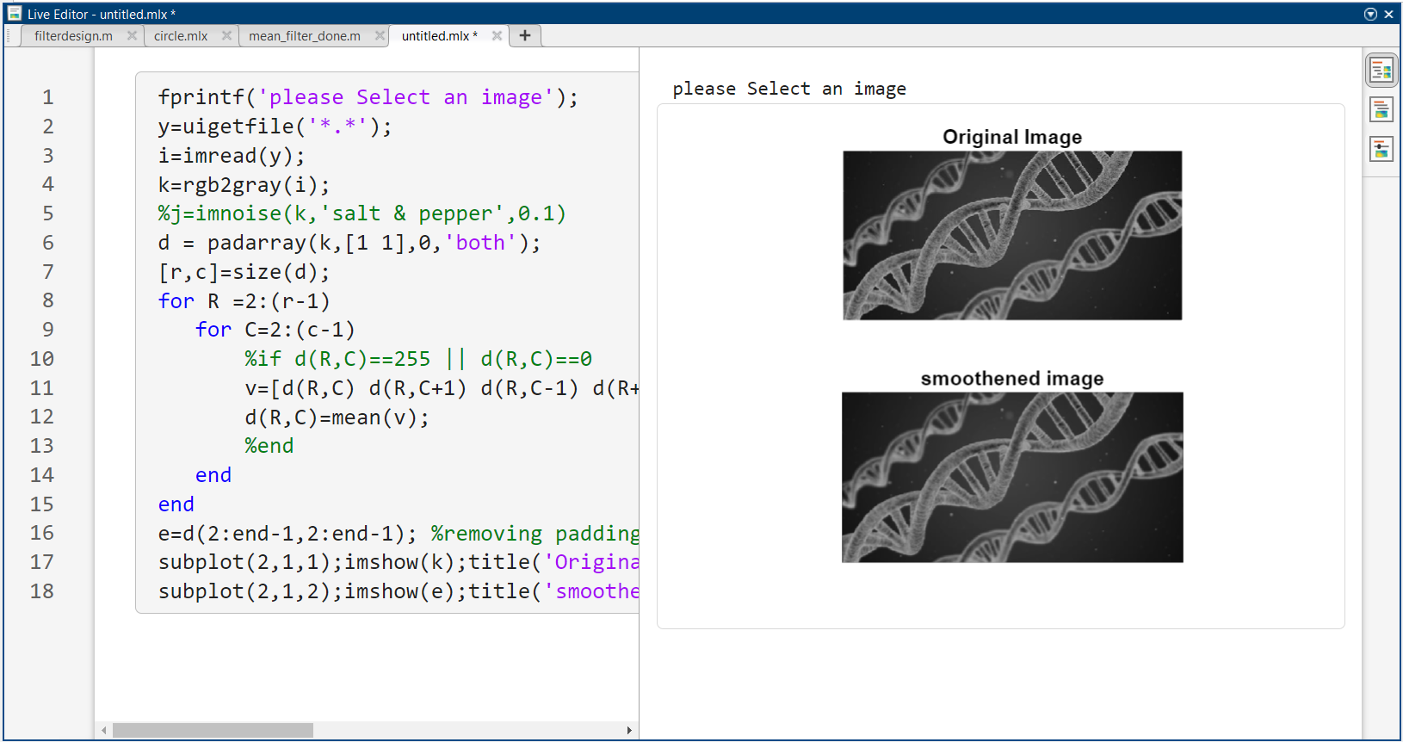

Figure 1: use of mean( ) and imnoise( ) function in MATLAB

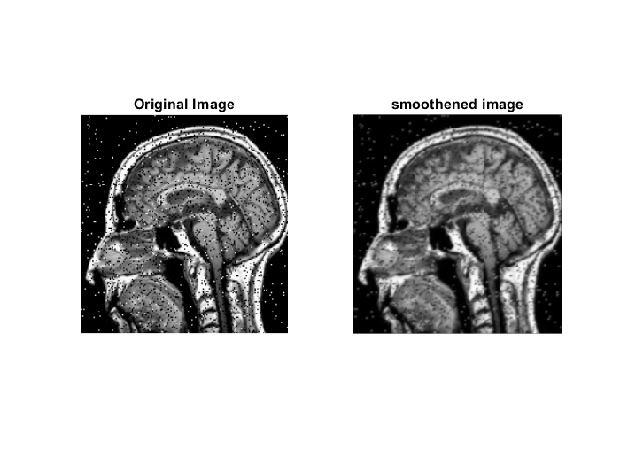

Figure 2: image smoothening using mean filter in MATLAB

##### **CODE**

% WEIGHTED MEAN FILTER

% Read the input image

inputImage = imread('s.jpg');

% Define the weights for the filter

weights = [1 5 1; 9 4 4; 7 2 9]/42;

% Apply the filter using imfilter

outputImage = imfilter(inputImage, weights);

% Display the input and output images side by side

subplot(1,2,1);imshow(inputImage);title('Original Image');

subplot(1,2,2);imshow(outputImage);title('smoothened image');

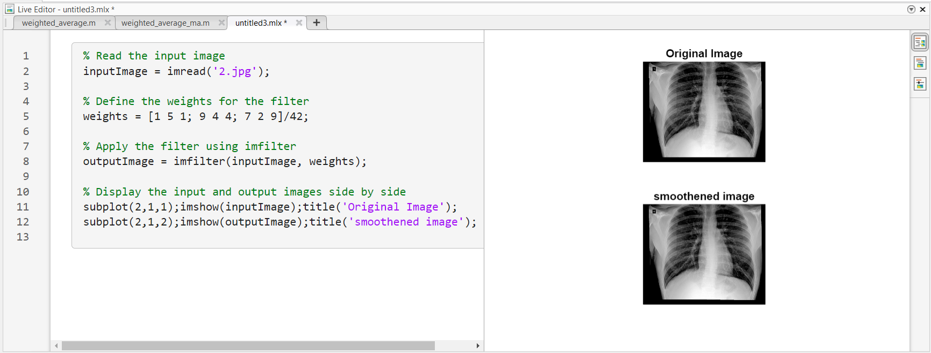

Figure 3: use of imfilter( ) function in MATLAB

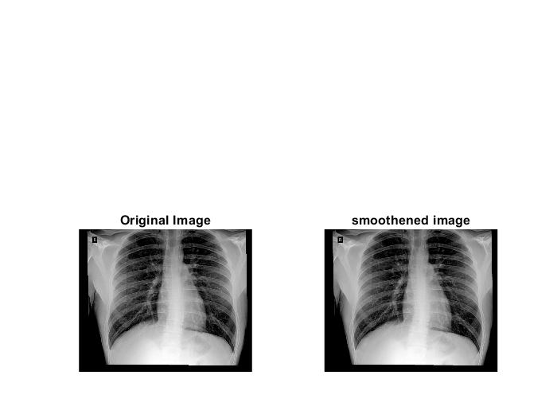

Figure 4: image smoothening using weighted mean filter in MATLAB

##### **POWER LAW TRANFORMATION / GAMMA CORRECTION**

**Gamma Filter:**

The Power law transformation, also known as gamma correction, is a type of image processing technique that alters the intensity values of pixels in an image using a power function. The power function can either increase or decrease the contrast of an image. In this technique, the image's pixel values are raised to a certain exponent (power) that changes the distribution of pixel intensities. The power function can be expressed as:

**s = c * r^γ**

Where s is the output pixel value, r is the input pixel value, γ is the gamma value, and c is a scaling constant. If the gamma value is less than 1, the resulting image will have increased contrast, making the darker pixels appear lighter and the lighter pixels appear darker. If the gamma value is greater than 1, the resulting image will have decreased contrast, making the darker pixels appear even darker and the lighter pixels even lighter.

Power law transformation is commonly used in image processing to correct for non-linearities in images caused by the imaging system or to enhance image contrast for better visualization.

##### **CODE**

% WEIGHTED MEAN FILTER

fprintf('please Select an image');

y1=uigetfile('*.*');

n=input('Please enter the value of gamma for Power law\n');

n=double(n);

J=imread(y1);

y2=rgb2gray(J);

y=double(y2);

%%

y3=y./255;

%%

y4=y3.^n;

%%

y5=y4.*255;

subplot(1,2,1);imshow(y2);title('Original Image');

subplot(1,2,2);imshow(y5,[]);title('gamma corrected image');

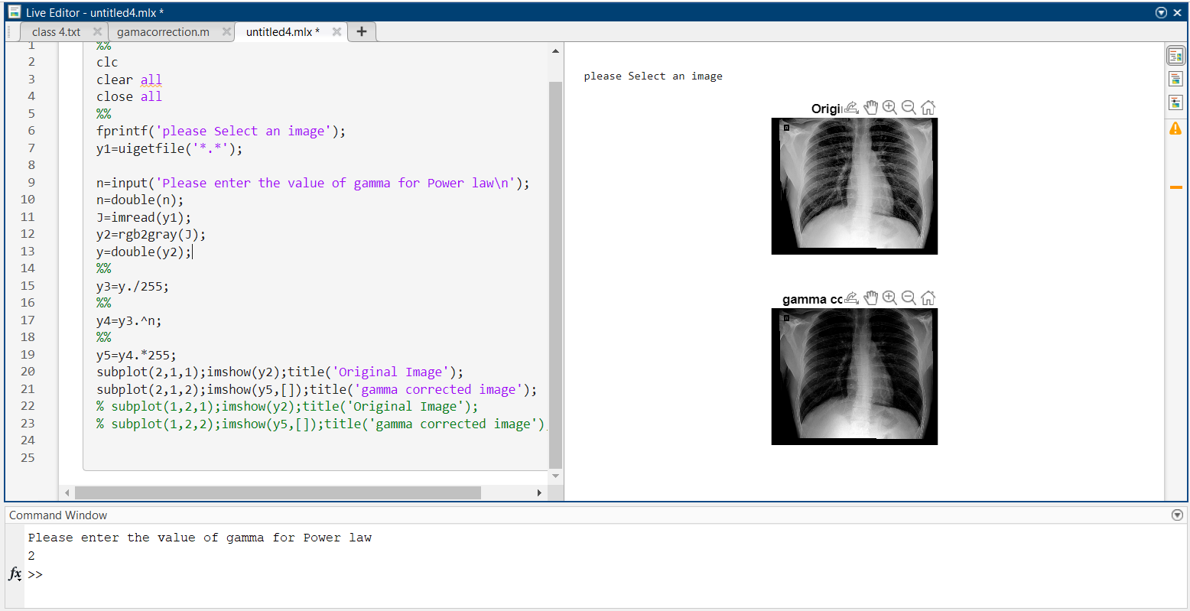

Figure 5: use of gamma filter in MATLAB

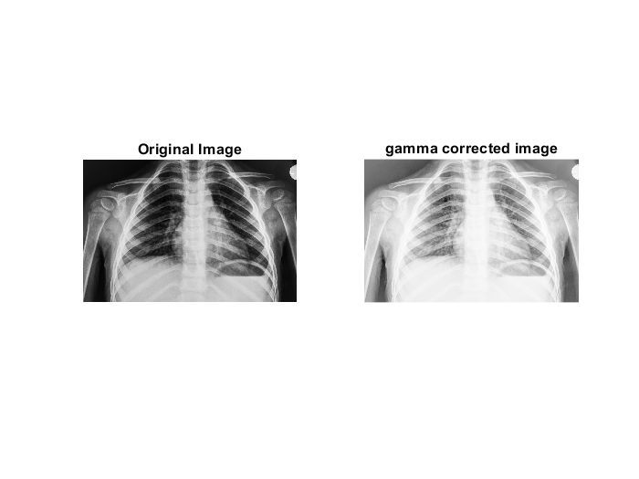

Figure 6: image enhancement using gamma filter in MATLAB

##### **IMAGE NEGATIVE**

**Negative Filter:**

An image negative is an inverted version of an original image. In a negative image, the dark areas of the original image appear light, and the light areas appear dark. This effect is achieved by reversing the brightness and colour values of the original image. New intensity values are given as.

**s = 255-i**

In medical imaging, negative images can be useful for highlighting certain features in an image. For example, a negative image of a CT or MRI scan can be used to enhance the contrast between different tissues or structures, making it easier for a medical professional to identify abnormalities or areas of interest. Negative images can also be used in radiography to highlight the presence of foreign objects, such as metal or glass, that may be difficult to see in a regular X-ray image. In these cases, the negative image can help to differentiate the foreign object from surrounding tissue or bone. Additionally, negative images can be useful for enhancing the visibility of certain types of medical images, such as angiograms or mammograms. By creating a negative image, it is possible to enhance the contrast between blood vessels or breast tissue and background structures, making it easier to identify potential abnormalities.

##### **CODE**

% NEGATIVE FILTER

fprintf('please Select an image');

y=uigetfile('*.*');

i=imread(y);

j=rgb2gray(i);

[r,c]=size(j);

newimg=255-i;

subplot(1,2,1);imshow(i);title('Original Image');

subplot(1,2,2);imshow(newimg);title('image negative');

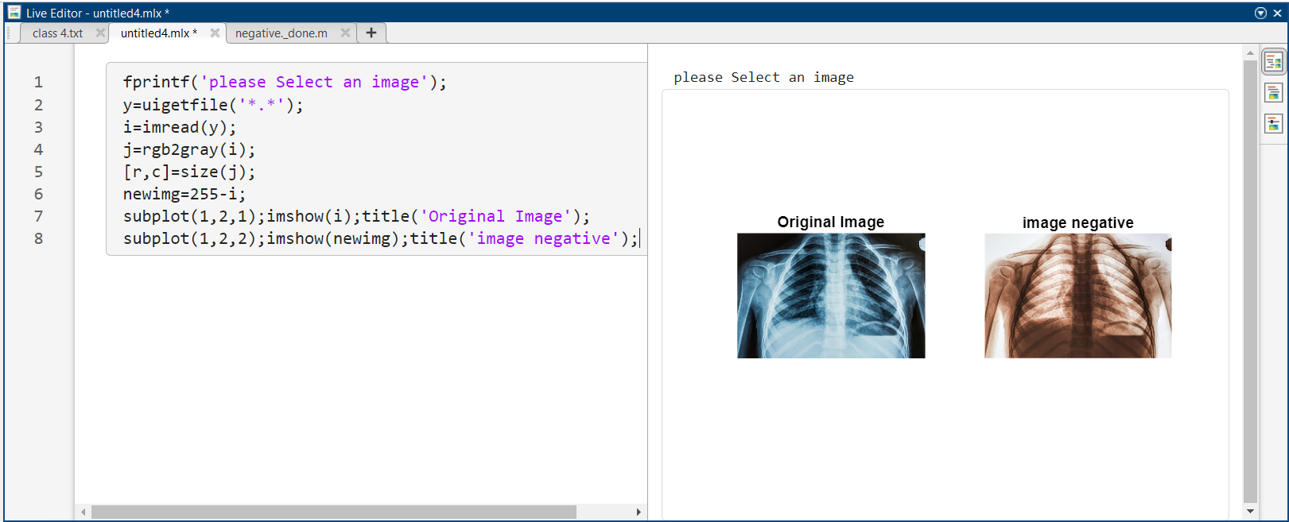

Figure 7: use of image negative filter in MATLAB

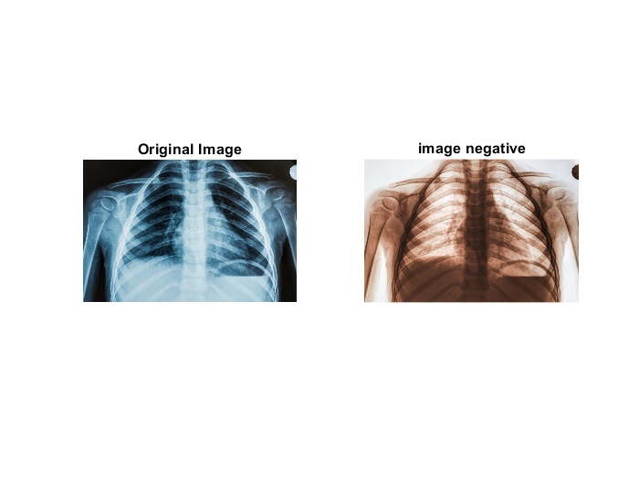

Figure 8: image enhancement using gamma filter in MATLAB

##### **BIT PLANE SLICING**

**Bit Plane Slicing:**

Bit plane slicing is a digital image processing technique used to separate the binary components of an image by extracting each bit plane. In digital imaging, each pixel in an image is represented by a binary code that can be divided into multiple bits. By using bit plane slicing, we can isolate each bit of the binary code, which results in a series of binary images. These binary images represent the contribution of each bit to the original image. For example, in an 8-bit grayscale image, the pixel values range from 0 to 255. We can slice the image into eight-bit planes, where the first bit plane represents the least significant bit (LSB) and the eighth bit plane represents the most significant bit (MSB). The MSB is the most important bit as it has the highest weight and contributes the most to the final pixel value. Each bit plane can be visualized as a binary image, where black pixels represent the bits that have a value of 0, and white pixels represent the bits that have a value of 1. By displaying each bit plane individually or in combination with other bit planes, we can enhance different features of the original image. For instance, the first bit plane would highlight the noise in the image, while the higher bit planes can help us to focus on the edges and details of the image.

Bit plane slicing is used in various applications such as image compression, feature extraction, and image enhancement.

##### **CODE**

% BIT PLANE SLICING

fprintf('please Select an image');

y=uigetfile('*.*');

i=imread(y);

% Convert image to grayscale

if size(i, 3) == 3

image = rgb2gray(i);

end

% Extract bit planes

bit_planes = zeros(size(image, 1), size(image, 2), 8);

for i = 1:8

bit_planes(:,:,i) = bitget(image, i);

end

% Display bit planes

figure;

for i = 1:8

subplot(2, 4, i);

imshow(bit_planes(:,:,i), []);

title(['Bit plane ', num2str(i)]);

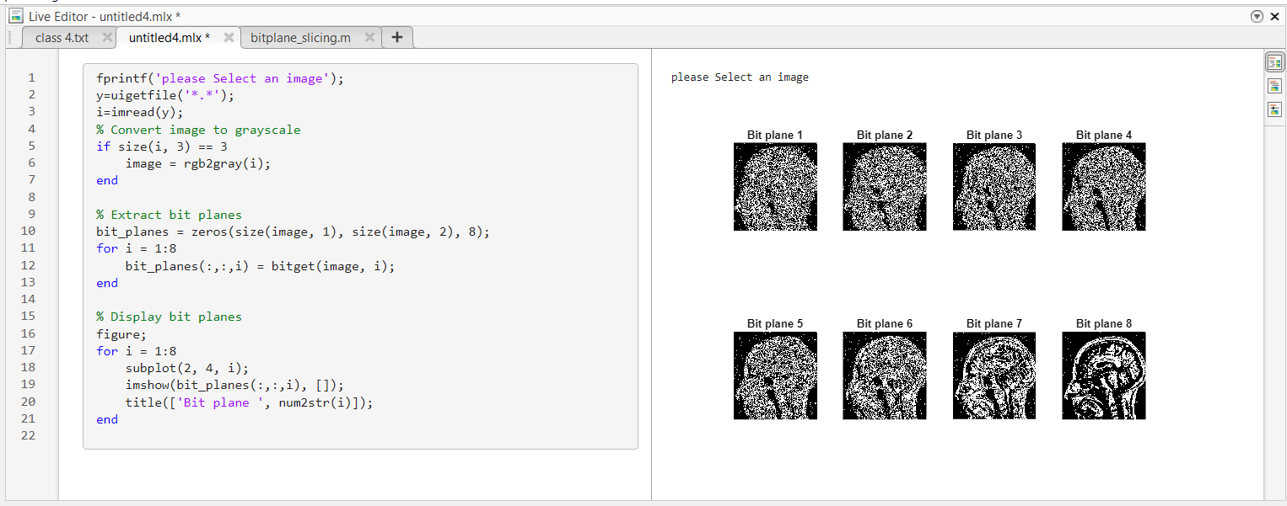

Figure 9: use of image bit slicing in MATLAB

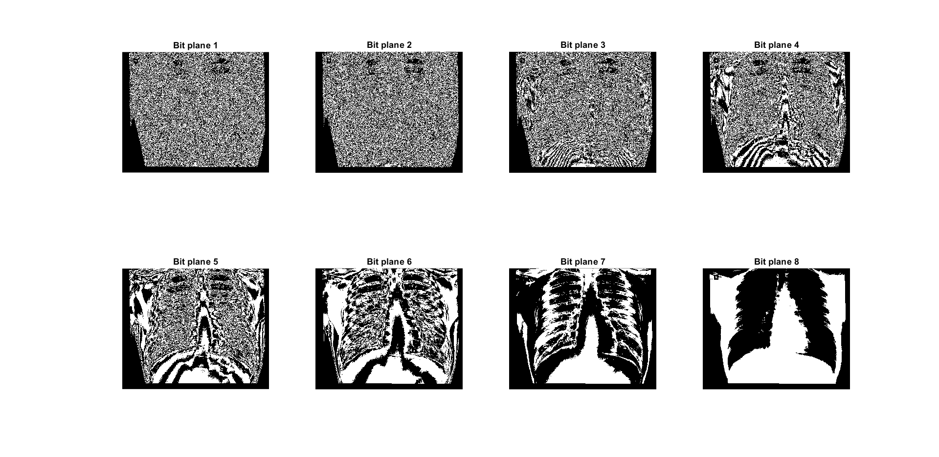

Figure 10: 8 bit sliced image in MATLAB

##### **CONTRAST STRETCHING**

**Contrast stretching:**

Contrast stretching is a technique used in image processing to enhance the contrast of an image. The technique works by expanding the dynamic range of the image so that the brightest and darkest pixels are spread over the entire range of pixel values, thus increasing the contrast. The process involves finding the minimum and maximum pixel values in the image, and then mapping the values in between to a new range. This new range is typically the full range of values that the image can represent, such as 0 to 255 for an 8-bit grayscale image. There are several methods for implementing contrast stretching, including linear stretching, piecewise linear stretching, and histogram equalization. Linear stretching involves simply scaling the pixel values between the minimum and maximum values to fill the entire range. Piecewise linear stretching involves dividing the range into several segments and applying a linear function to each segment. Histogram equalization involves mapping the histogram of the image to a uniform distribution. Contrast stretching is a useful technique for enhancing the visibility of details in an image, particularly when the contrast is low. However, it can also lead to artifacts and noise amplification if not applied carefully. Therefore, it is important to choose an appropriate method and parameter settings for each specific image.

##### **CODE**

% CONTRAST STRETCHING

im=imread("Xray_share.jpg");

img=rgb2gray(im);

I=double(img);

x=[0 40 150 250];

y=[0 90 170 200];

plot(x,y);

[rows,columns]=size(I);

for r=1:rows

for c=1:columns

if I(r,c )<x(2)

I(r,c )=(y(2)/x(2))*r;

elseif I(r,c)>=x(2) && I(r,c)<x(3)

I(r,c)=((y(3)-y(2))/(x(3)-x(2)))*(r-x(2) );

else

I(r,c)=((y(4)-y(3))/(x(4)-x(3)))*(r-x(3) );

end

end

end

figure,

imshow(I);

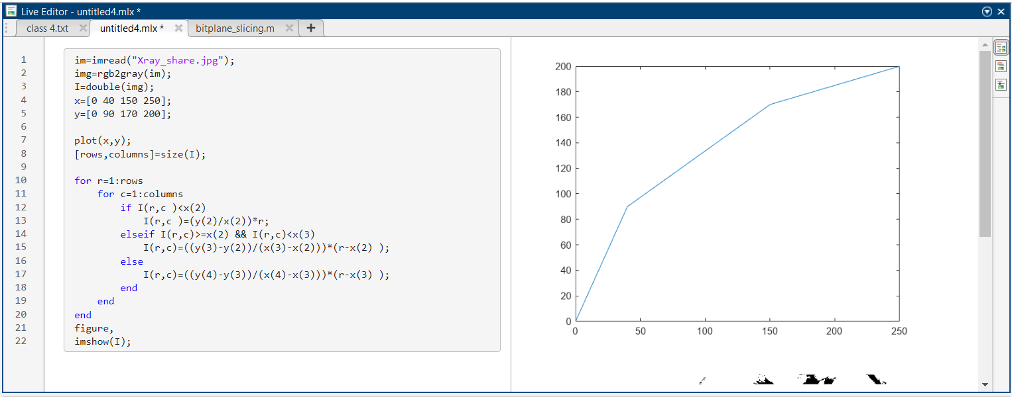

Figure 11: use of contrast stretching in MATLAB

##### **MIN AND MAX FILTER**

**Min and Max filter:**

In image processing, a min filter (also known as erosion) is an operation that replaces each pixel in an image with the minimum value of its neighbouring pixels, using a kernel or structuring element. The result is an image that has had small features or details removed, effectively shrinking the image. On the other hand, a max filter (also known as dilation) replaces each pixel in an image with the maximum value of its neighbouring pixels. This operation has the opposite effect of the min filter, and can be used to enhance or highlight the edges and boundaries in an image.

Both min and max filters are used in image processing for various purposes, such as noise reduction, feature extraction, and object detection. They can be applied to grayscale as well as colour images. The size and shape of the kernel or structuring element used for the filtering process determines the degree of smoothing or sharpening in the resulting image..

##### **CODE**

% MIN FILTER

fprintf('please Select an image');

y=uigetfile('*.*');

i=imread(y);

k=rgb2gray(i);

j=imnoise(k,'salt & pepper',0.1);

d = padarray(j,[1 1],0,'both');

[r,c]=size(d);

for R =2:(r-1)

for C=2:(c-1)

if d(R,C)>=250

v=[d(R,C) d(R,C+1) d(R,C-1) d(R+1,C) d(R+1,C-1) d(R+1,C+1) d(R-1,C) d(R-1,C-1) d(R-1,C+1)];

d(R,C)=min(v);

end

end

end

e=d(2:end-1,2:end-1); %removing padding

subplot(1,3,1);imshow(i);title('Original Image');

subplot(1,3,2);imshow(j);title('salt and pepper noised');

subplot(1,3,3);imshow(e);title('salt removed');

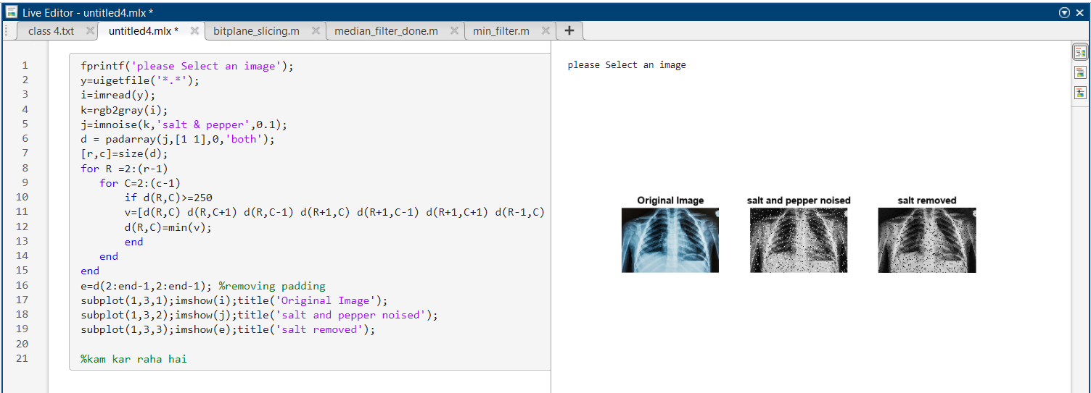

Figure 12: use of min() function for making min filter in MATLAB

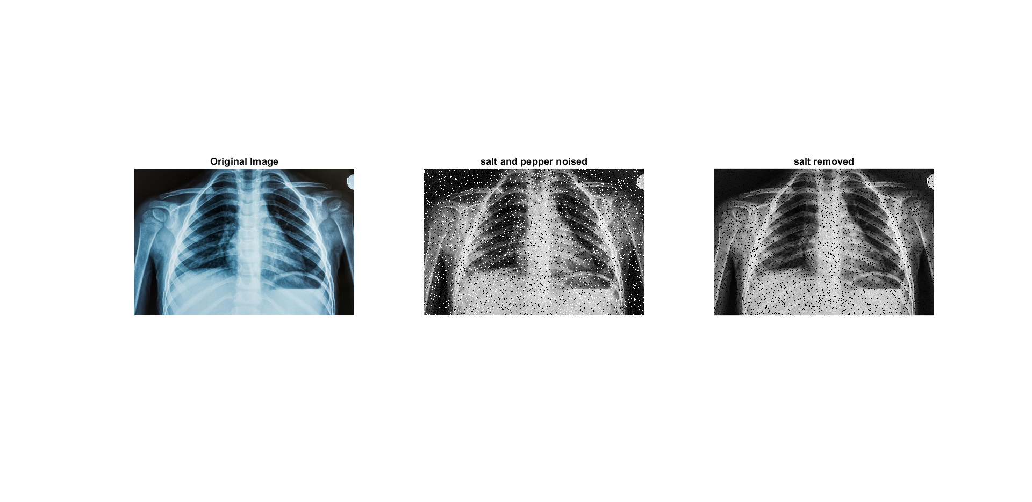

Figure 13: min filter in MATLAB is able to filter only salt noise.

##### **CODE**

% MAX FILTER

fprintf('please Select an image');

y=uigetfile('*.*');

i=imread(y);

k=rgb2gray(i);

j=imnoise(k,'salt & pepper',0.1);

d = padarray(j,[1 1],0,'both');

[r,c]=size(d);

for R =2:(r-1)

for C=2:(c-1)

if d(R,C)<=10

v=[d(R,C) d(R,C+1) d(R,C-1) d(R+1,C) d(R+1,C-1) d(R+1,C+1) d(R-1,C) d(R-1,C-1) d(R-1,C+1)];

d(R,C)=max(v);

end

end

end

e=d(2:end-1,2:end-1); %removing padding

subplot(1,3,1);imshow(i);title('Original Image');

subplot(1,3,2);imshow(j);title('salt and pepper noised');

subplot(1,3,3);imshow(e);title('pepper removed');

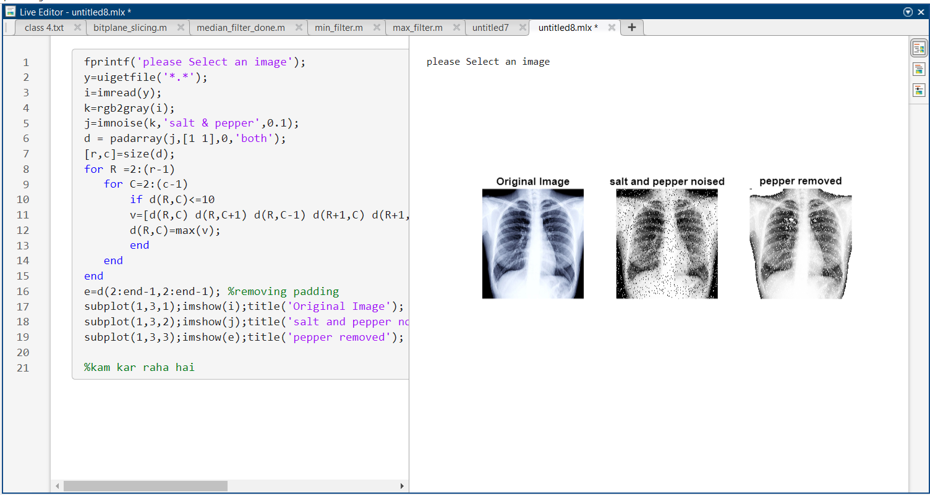

Figure 14: use of max() function for making max filter in MATLAB

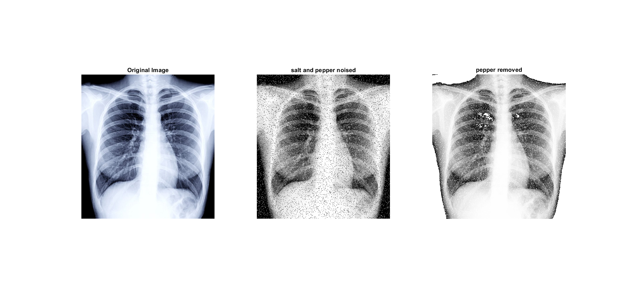

Figure 15: max filter in MATLAB is able to filter only pepper noise.

##### **MEDIAN FILTER**

**Min and Max filter:**

A median filter is a digital signal processing technique used to remove noise from a signal or an image. It works by replacing each pixel's value with the median value of its neighbouring pixels. The process of median filtering involves sliding a window (typically a square or rectangular shape) over the input signal or image. For each pixel within the window, the median value of the pixel's neighbourhood is calculated and used as the new value for that pixel. The size of the window determines the extent of smoothing applied to the signal or image.

Median filtering is commonly used in image processing to remove salt and pepper noise, which appears as random black and white pixels in an image. The median filter can effectively remove this type of noise without blurring or distorting the image's edges and details, making it a popular choice for image denoising.

##### **CODE**

% MEDIAN FILTER

fprintf('please Select an image');

y=uigetfile('*.*');

i=imread(y);

k=rgb2gray(i);

j=imnoise(k,'salt & pepper',0.1);

d = padarray(j,[1 1],0,'both');

[r,c]=size(d);

for R =2:(r-1)

for C=2:(c-1)

%if d(R,C)==255 || d(R,C)==0

v=[d(R,C) d(R,C+1) d(R,C-1) d(R+1,C) d(R+1,C-1) d(R+1,C+1) d(R-1,C) d(R-1,C-1) d(R-1,C+1)];

d(R,C)=median(v);

%end

end

end

e=d(2:end-1,2:end-1); %removing padding

subplot(1,3,1);imshow(i);title('Original Image');

subplot(1,3,2);imshow(j);title('salt and pepper noised');

subplot(1,3,3);imshow(e);title('noised removed');

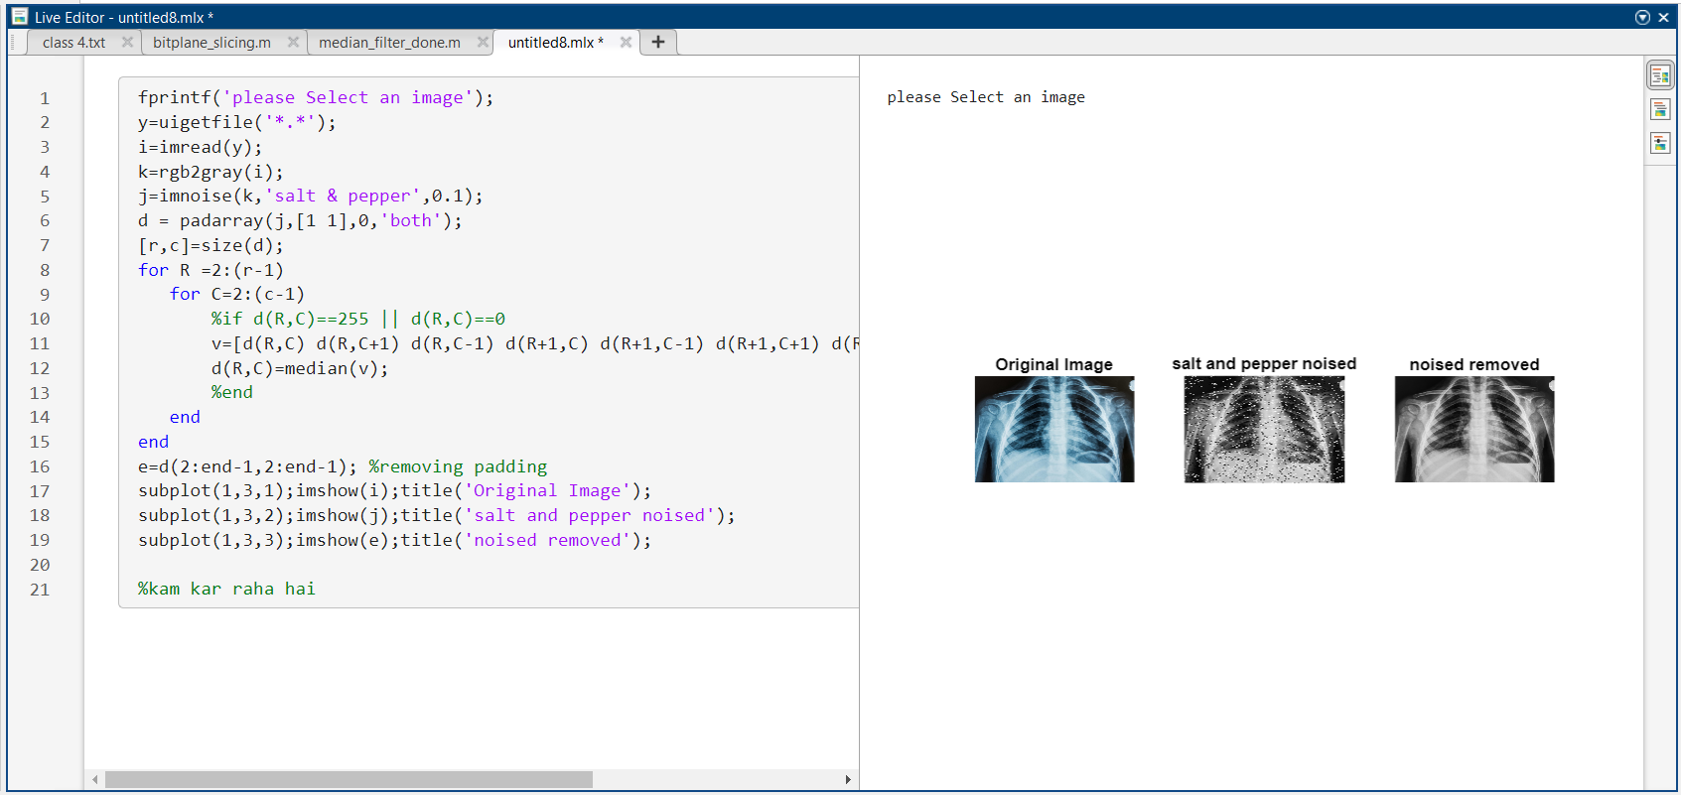

Figure 16: use of median() function for making median filter in MATLAB

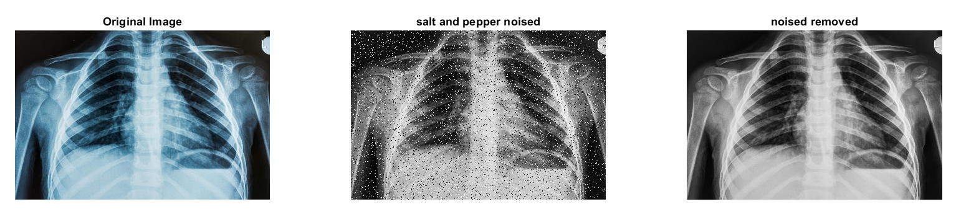

Figure 17: median filter in MATLAB is able to filter both salt and pepper noise.

---------------------------------------------

Shreenandan Sahu |120BM0806